# Default Courses

Contents

Default Courses 1

Overview 2

Notable Behaviours 2

Installation 2

Testing 3

Test cases setup 3

Test cases 3

Algorithms / Code Changes 4

Database changes 4

Code changes 4

Settings 4

## Overview

This custom local plugin allows an administrator to choose one or more courses that are considered “default” courses. All users in Moodle (apart from the Moodle site administrator and guest accounts) will be enroled as students in these selected course(s). The plugin takes advantage of the Moodle CRON to check for new users that need to be enroled in the default courses.

### Notable Behaviours

#### Users

* All users will have ‘student’ access to all of the courses defined in the Default Courses plugin settings

#### Administrators

* A new ‘Default Courses’ local plugin settings page will be visible in the Site Administration block

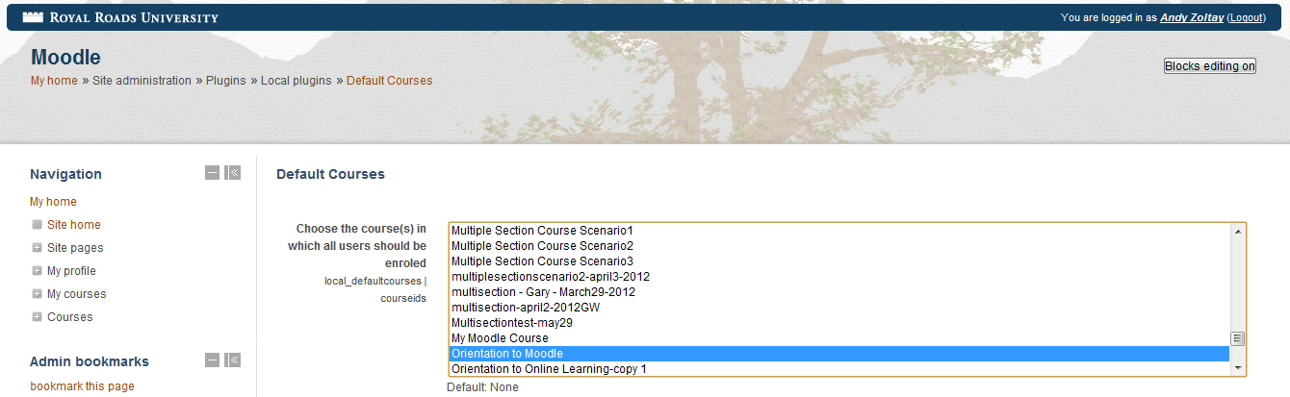

* Use the <Ctrl> key and/or the <Shift> to multi-select courses
* No feature has been developed to un-enrol users from the default course(s) if they are unselected in the settings screen. This was done purposely since the system cannot know which users to un-enrol and which ones to keep.

## Installation

1. Navigate to the *local* folder in the Moodle structure
   1. cd /var/web/wwwroot/moodle/local
2. Export the installation package from SVN
   1. svn export –force svn+ssh://yoursvnuser@whiskey/var/lib/svn/moodle/Moodle/2.1.2/INSTALLS/draftposts/defaultcourses_***version***.tgz
3. Untar the installation files in the *local* folder
   1. cd defaultcourses
   2. tar -zxvf defaultcourses_***version***.tgz
   3. Update Moodle Cron interval at which the default course enrolment occurs. The default value is 360 seconds (every hour)
   4. Update the version.php file – set $plugin->cron = *newvalue*;
4. Clean up the install files
   1. rm ../defaultcourses_***version***.tgz
5. Log onto the Moodle instance with an admin account and press the “Upgrade” button when the “Plugins check” screen appears
   1. You should see “local_defaultcourses” Success followed by a “Continue” button – click it
   2. You should see “New settings – Default Courses”
      1. The administrator has the option to select one or more courses here or later through the Site administration block – Plugins->Local plugins->Default Courses
      2. Click “Save changes” to continue

## Testing

### Test cases setup

Choose an existing course (or create a new course) that doesn’t have anyone enroled in it as a default course.

As a Site Administrator set the option to all the Moodle cron to be run in a browser

1. In the Settings block go to Site administration->Security->Site policies
2. Make sure the “Cron execution via command line only” check box is unchecked
3. “Save changes”, if necessary

NOTE: This should be changed back once testing is complete

### Test cases

1. Test initial enrolment
   1. Login to Moodle with an account that has Site Administration privileges
   2. View the enrolment for a “candidate” course for default course
      1. Navigate to the course
      2. View the enrolment by clicking on the “Enrolled users” menu item under Course administration->Users in the Settings block
      3. No users should be enroled
   3. Set the default course
      1. Navigate to Site administration->Plugins->Local plugins->Default Courses
      2. Select the course from the list of courses
      3. Click save changes
   4. Manually run the Moodle Cron
      1. Browse to this URL: *moodlepath*/admin/cron.php
      2. The output of the cron is displayed in the browser - you should see the following in the script:

Processing customized cron scripts ...Processing cron function for local_defaultcourses...

Enrol users in default course: *Name of the course*

* 1. Confirm enrolment
     1. Navigate to the course
     2. View the enrolment by clicking on the “Enrolled users” menu item under Course administration->Users in the Settings block
     3. All users should be enroled (apart from the guest and admin account)

1. Test deleting a student’s enrolment from a course defined as a default course
   1. In the enrolment screen of the default course chosen in test case 1, delete 2-3 of the student enrolments
      1. On the far right hand side of the screen click the red “x” icon under the “Enrolment methods” column for the students you want to un-enrol.

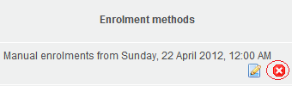

* + 1. Make note of the names of the students for later verification
  1. Manually run the Moodle Cron
     1. Browse to this URL: *moodlepath*/admin/cron.php
     2. The output of the cron is displayed in the browser - you should see the following in the script:

Processing customized cron scripts ...Processing cron function for local_defaultcourses...

Enrol users in default course: *Name of the course*

You should also see that 2-3 (depending on how many users were un-enroled) users will have been enroled in the course you chose as a default course

* 1. Confirm enrolment
     1. Navigate to the course
     2. View the enrolment by clicking on the “Enrolled users” menu item under Course administration->Users in the Settings block
     3. Search for the 2-3 users you un-enroled
     4. The users should be enroled including all other users (apart from the guest and admin account)

## Algorithms / Code Changes

### Database changes

The plugin does not make any database object changes.

### Code changes

This plugin makes no changes to core Moodle functionality.

Defaultcourses plugin files are stored in the /local/defaultcourses folder

* /lang/en/local_defaultcourses.php – language strings specific to defaultcourses plugin
* lib.php – defaultcourses specific functions
* settings.php – handles defaultcourses plugin settings (like choose default courses)
* version.php – Moodle version management file and Moodle CRON management specific to defaultcourses

### Settings

Under the Site administration -> Plugins -> Local plugins -> Default Courses

**Choose the course(s) in which all users should be enroled** (local_defaultcourses|courseids) – defines which courses will have all users enroled as students